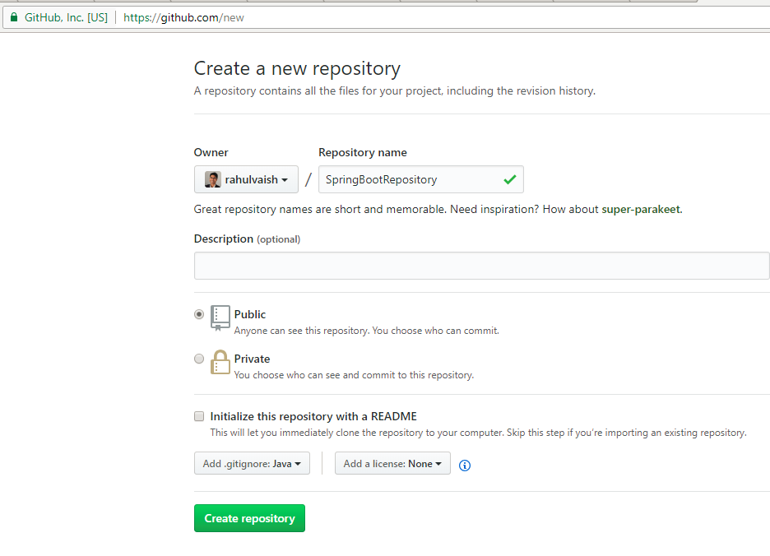

After creating the repository, copy the URL:

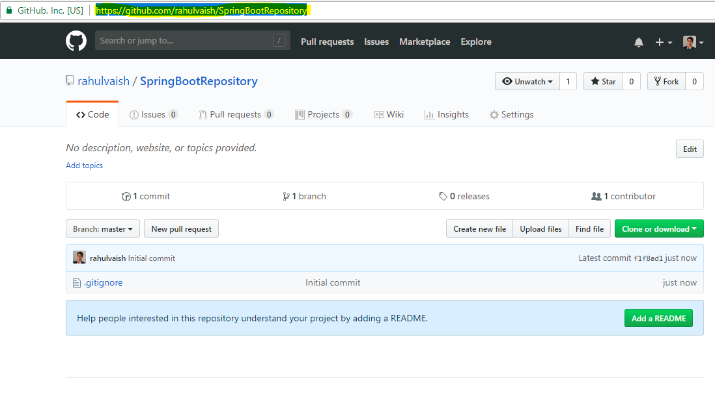

In any folder Right Click-> Git Clone

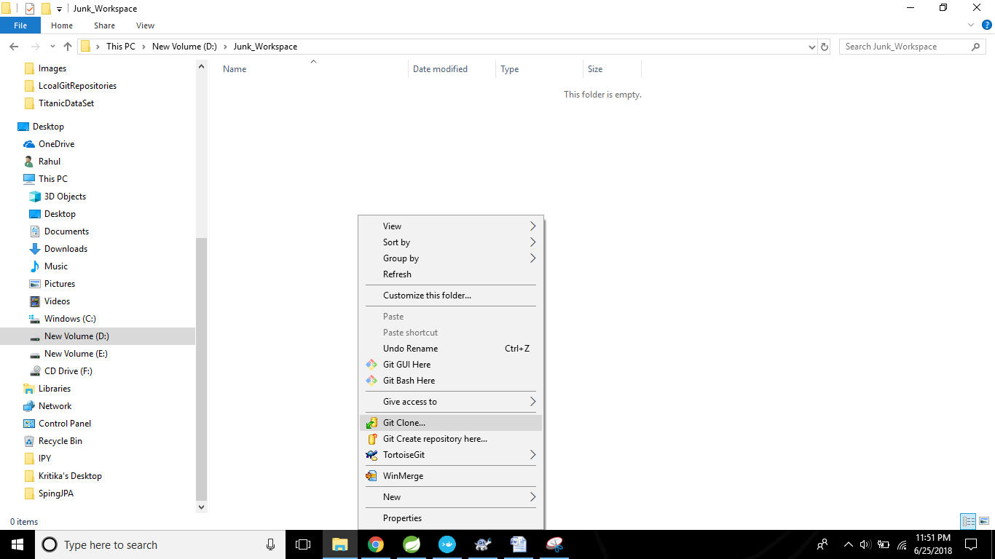

Paste the URL,that was copied earlier:

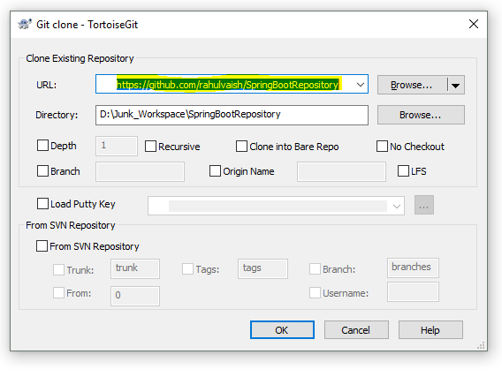

Click on OK.

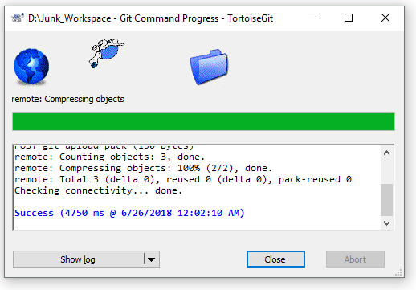

Just to be curious, if we see what got cloned from an empty repository:

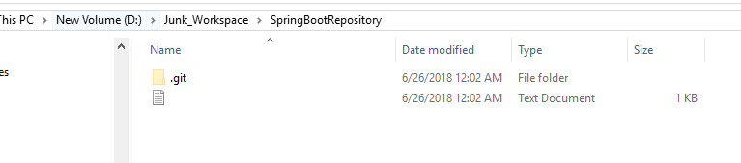

Now copy the project from your workspace

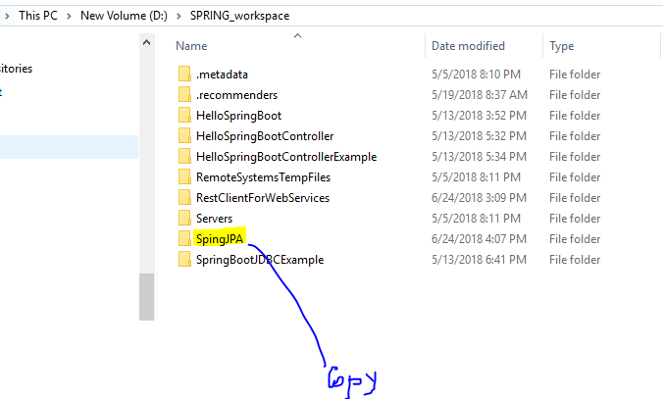

And paste the same inside the newly created folder where we performed ‘Git Clone’

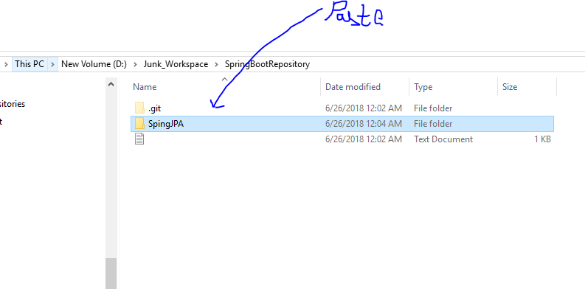

Now, initiate the Git Bash Here -

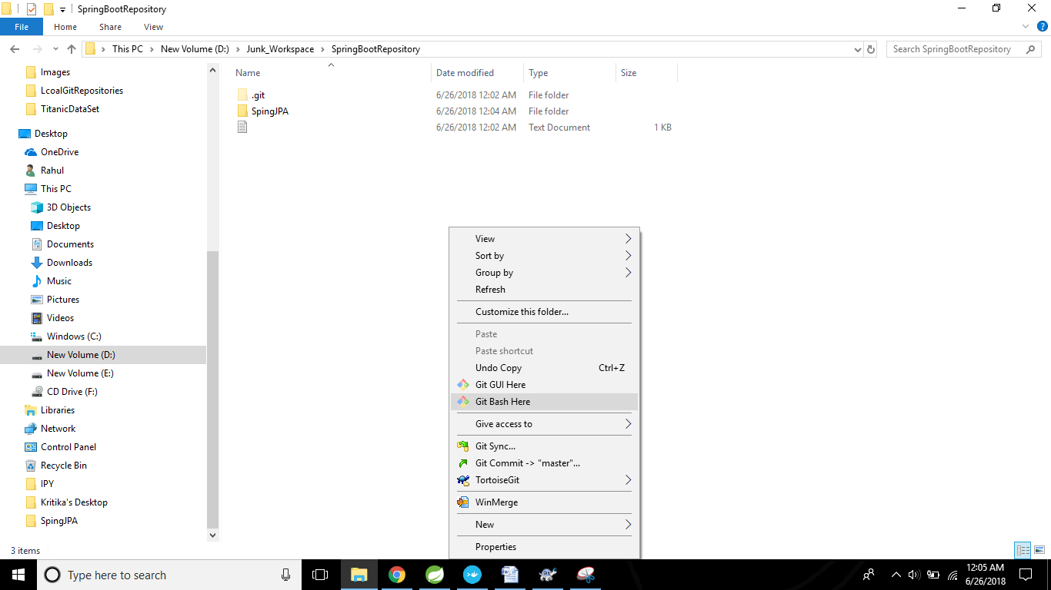

Step#1: The new comer is marked as **Red**

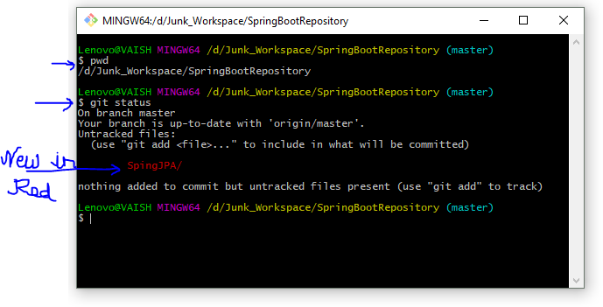

Step#2: Registering:

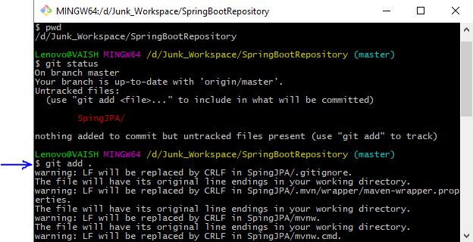

Step#3: Checking the status again. It looks **Green**.

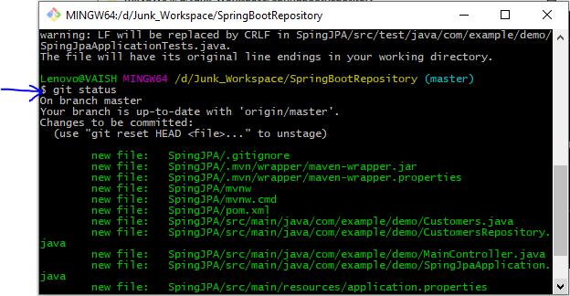

Step#4: Commit

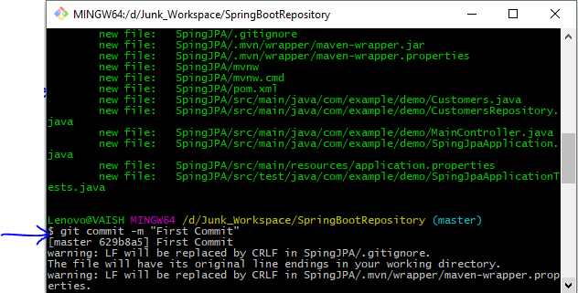

Step#5: Pushing the commit

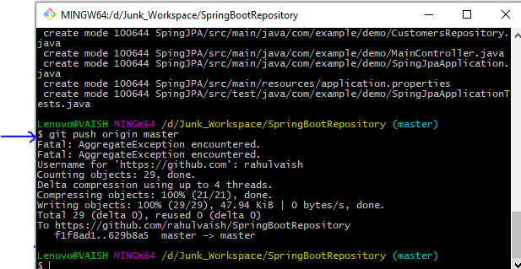

Step#6: Check Github.com

